8. SIMPLE PLANAR MECHANISM
TOM
KOM (Kinematics): Without Force | DOM (Dynamics): With Force
 | Statics (Neglecting Inertia) | Kinetics (Considering All forces)
- KOM: In it, we discuss about relative motion & relative acceleration between different parts of machine.
- DOM: In it, we considered the forces acting on different parts of machine analysis.
- If inertia of members is neglected the analysis is known as “Statics of machine”.
- If inertia Force/ Torque is considered it is known as “kinematics of machine”.
Engineering Mechanics
Statics | Dynamics (With considering motion)
 | Kinetics (With force) | Kinematics (Without force)
- LINK/ ELEMENT: It is smallest unit of a machine.
- It should be resistant body it need not to be rigid always. But it must be capable of transferring the relative motion.
Type of Bodies
Rigid Body | Deformable Body
 | Solids | Liquids (Continuously Deforming)
- Different parts manufactured separately & if it does not have relative motion between then when joined together, it will consider as a single link.
Classification of links
Rigid | Deformable (Resistant)
- Flexible link possesses one directional rigidity.
Spring: It’s used to exert the restoring force. It’s not a link.
- Each link must have at least 1 node.
- JOINTS: The inter connection between 2 or several links such that it can transfer of relative motion will be known as pair.
CLASSIFICATION OF PAIRS:
- ON THE BASIS OF DOF: The minimum number of independent of Pair/ Variable/ Displacement/ Coordinates required to defined the motion of the body is known as DOF.
DISPLACEMENT OR PAIR VARIABLE
Translational: Total 3 DOF ($S_{x},S_{y},S_{z}$) | Angular: Total 3 DOF ($θ_{x},θ_{y},θ_{z}$)
 | Rotational | Oscillation
- When object moves in 3D space and $+ \& -$ axis motion is considered, then DOF is 6. Same way ${DOF}_{2D}=3$.
OBSERVATIONS:
- Pair are responsible for restriction in DOF
- $Actual Possible DOF= Max Possible DOF – Restricted DOF$
Sr. No. | Name | Abbreviations |  | DOF | Displacement Variables |  | 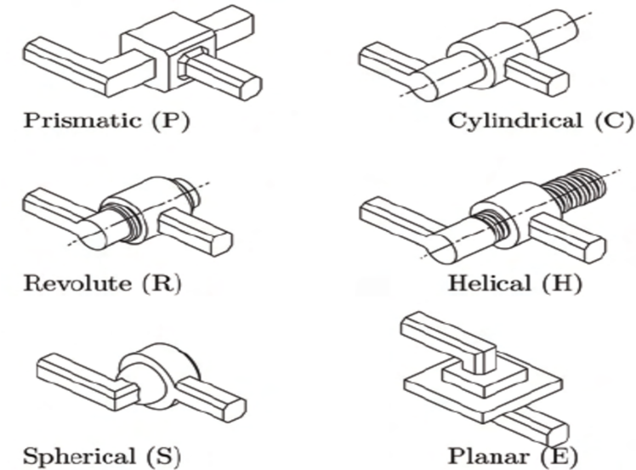 | 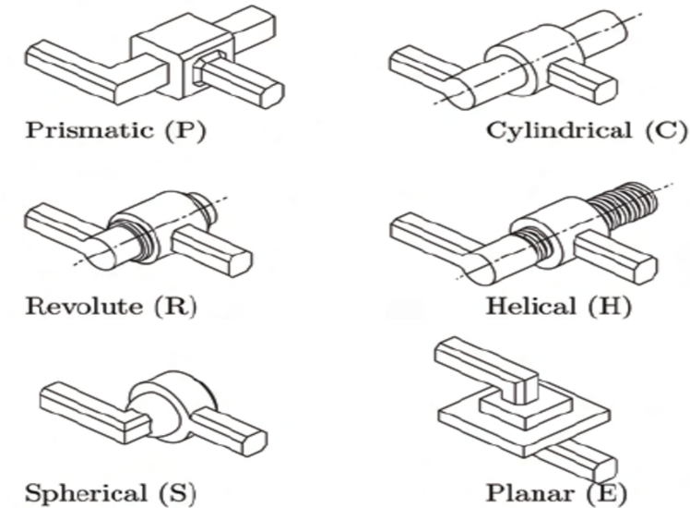
1 | Cylindric | C- Pair |  | 2 | $$S_{x}, θ_{y}$$
2 | Prismatic/ Sliding | P- Pair |  | 1 | $$S_{y}$$
3 | Revolute/ Hinged | R- Pair |  | 1 | $$θ_{y}$$
4 | Screw/ Helix | H- Pair |  | 1 | $$S_{y} or θ_{y}$$
5 | Globular/Spherical | G- Pair |  | 3 | $$θ_{x},θ_{y},θ_{z}$$
6 | Planar/ Evena | E- Pair |  | 3 | $$S_{x},S_{y}, θ_{z}$$
- Shaft in bearing.  - Piston is the cylinder of IC engine.  - Nut/ Screw. |  |  | Z |  |  | Y
 |  |  |  |  |  | X
 |  | Lead is related with angle and displacement hence, screw pair has only 1 DOF.
NOTE: All of the above 6 pairs are having area contact between matting elements.
- CLASSIFICATION OF PAIR ON THE BASIS OF CONTACT:
- LOWER PAIR: If there is area contact between mating elements, the pair formed is known as lower pair.

LOWER PAIR (On the basis of DOF)
Linear Motion Pair ($DOF=1$) E.g. R, P, H | Surface Motion Pair ($DOF>1$) E.g. C, G, E
It’s also known as Hartenberg -Reaulng Pairs.
- In planer mechanism only linear motion pairs can be used.
NOTE: Each linear motion pairs in planar condition (E.g. Whenever used in planar chain or planer mechanism) will restricted 2 DOF.
- HIGHER PAIR: If there is negligible are of contact between two links or there is either point or line contact, the pair is known as higher pair.
- Except 6 pair discussed earlier all other pair falls under this category, therefore there is infinite possibility of higher pairs. E.g. Gear & Pinion, Cam & Follower, mechanism.
- WRAPPING PAIR: there is a special case of higher pair known as wrapping pair, in it, one link will be wrapped over another link. E.g. Chain & Sprocket, Belt & Pully, etc.
- According to Hertenberg, the pair which cannot be inverted are known as higher pair & the pairs which can be inverted are lower pair.
- Inversion is possible only when the locus of the links must be same when moves one on other fixing second & vice versa.
CASE-I: Belt is sliding over the pully in area AB & CD. Hence, there is area contact and it will form lower pairs.  CASE-II: If belt is not sliding over the pully. Hence, there won’t be any relative motion between belt and pully in the portion AB & CD. So, Belt and pully will form a same link in the portion AB & CD. So, there will be no pair in AB & CD. | 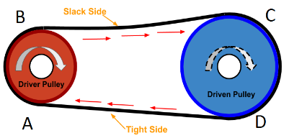
- Relative motion between belt and pull will exist at points A, B, C, D. So, at these points belt and pully will be considered as separate links. $No. of higher pairs = 4$
INVERSION: The process of fixing different links and obtaining mechanism is known as inversion.
E.g. Mechanism is Circle Pure rolling over the Staring line.
CASE-I: Straight line is fix. Cycloidal profile will obtain by tracing point on the circle | CASE-II: Circle is fix. Involute profile will obtain by tracing point on the Straight line.
- Hence, the inversion of higher pair is not possible.
DOF OF HIGHER PAIRS:
Higher pair (Rolling motion)
Pure Rolling. E.g. $DOF=1$ | Rolling With slipping. E.g. $DOF=2$

Bearing
Sliding Contact | Rolling Contact
Journal Bearing: In motion, It will form lower pair. In Non-motion, It will form Higher pair. | Ball Bearing:  It will always form higher pair.
- Bearing is a mechanical element which is used to support the shaft & bearing the various load is acting on the shaft & rotor. Bearing permits relative motion of the shaft but it can’t transfer the relative motion & hence bearing are not kinematic Pair.
LOWER PAIR | HIGHER PAIR
Area/ Surface Contact | Line/ Point Contact
Known as Full joint | Known as Half Joint
Can be inverted | Can’t be inverted
$$DOF≥0$$ | $DOF=1$ For Pure Rolling & $DOF=2$ For Rolling with slipping
More Friction | Less Friction (Anti Frictional Bearing)
Large Load Caring capacity | Less Load Caring capacity
Can hold/ entrap more quantity of lubricants. | Can hold/ entrap less quantity of lubricants.
- Each higher pair whenever used in planar chain or planar mechanism will be equivalent to 2 linear motion pair. Therefore, each higher pair in a planar mechanism permits 2 DOF & restricts 2 DOF.
- ON THE BASIS OF TYPE OF CLOSURE:
- OPEN PAIR: If a link is simple kept on another link that is not inserted, the pair is known as open pair. E.g. Cam & Follower.
- CLOSED PAIR: If a link is inserted in another link, the pair is formed is known as closed pair.
- To assembled the closed pair, failure of one pair is necessary where as in case of open pair the link can be separated without failure.
One more classification:
- Form Closed Pair: If the contact between, mating element is due to their geometrical specification is known as formed closed pair.
- Forced Closed Pair: If the contact between, mating element is due to some force either weight of the element or due to some other force such as spring force. Such pair is known as forced closed pair.
- ON THE BASIS OF NO. OF LINK CONNECTED:
BINARY PAIR | TERNARY PAIR | QUATERNARY PAIR
2 Links at a node | 3 Links at a node  $$1T=2B$$ | 4 Links at a node  $$1Q=3B$$
- ON THE BASIS OF TYPE OF CONSTRAINED:
- INCOMPLETELY CONSTRAINED PAIR (ICP): This is possible relative motion is of more than 1 type or in more than 1 direction, the pair is known as incompletely constrained pair. E.g. $DOF>1$
- COMPLETELY CONSTRAINED PAIR (CCP): This is possible relative motion is of only 1 type or in only 1 direction, the pair is known as CCP. E.g. $DOF=1$
- SUCCESSFULLY CONSTRAINED PAIR (SCP): If ICP is converted into CCP either with the help of some force (External or self-weight) or with the help of some other link, the pair is called as SCP. E.g. $DOF=1$
E.g. 1) Piston in a cylinder ($DOF=2$) is ICP. But Piston in a cylinder of IC engine ($DOF=1$) is SCP.
2) Shaft in Journal bearing ($DOF=2$) is ICP. But Shaft with collar in Journal bearing ($DOF=1$) is CCP. Where as shaft in Step bearing ($DOF=1$) is SCP.
- CHAIN: Assembly of various links & pairs which permits the transfer of relative motion is known as chain.
- If the 1st link is connected directly or indirectly to the last link, then it’s known as Closed Pair.
- If the 1st link is not connected to the last link, then it’s known as Open Pair which is mainly used in robotics.
- MECHANISM/ LINKAGE: If any one link of the chain is fixed & it can transfer the relative motion with or without the transformation of motion, it will be known as mechanism.
INVERSION OF MECHANISM: The process of fixing different links of chain/ mechanism and obtaining chain/ mechanism is known as inversion.
- Every inversion result in a unique mechanism or ever mechanism has it’s own inversion.
- No. of possible inversion of a mechanism is equal to the number of different links in mechanism.
- Inversion can’t affect the ability to transfer the relative motion between links as it is fundamental property of parent kinematic chain.
- Inversion of higher pair mechanism is not possible.

- MACHINE: It’s an assembly of various links, pairs, chains & mechanisms such that it can transfer relative motion, force / torque from source to the load with or without transformation.
- Machine can transfer some form of available energy from source to some other form of energy at the load.
MACHINE Vs. MECHANISM: every machine is a mechanism in sprite where as reverse is not true.
- Machine may consist of one or several mechanisms. E.g. Clocks, typewriter, keyboard all are mechanisms.
- Mechanisms are simple model of any complete machine.
MOBILITY ANALYSIS OR DOF OF PLANAR MECHANISM:
PLANAR MECHANISM: The mechanism in which the locus of different points on different links lies on parallel planes is known as planar mechanism.
- The kinematic representation of any planar mechanism can be drawn on a single plane.
MOBILITY ANALYSIS OF CHAIN: In planar chain/ mechanism all the links will move on parallel planes.
$${DOF}_{Planar {Chain}/{Mechanism}}=3\left(∵Planar links has only 2 Translation \&1 Rotation DOF\right)$$
Hence, for “$n$” No. of links in a chain has, $\max{DOF}=3n$.
$Actual DOF=\max{DOF}-Restricted DOF,$ Where Restricted DOF is due to pairs.
CONSTRAINED DOF DUE TO LOWER PAIR:
- Linear Motion pair ($DOF=1$)  - Only (Equivalent) Binary Joints ($j$)  - Each linear motion pair restricted $2 DOF$ in planar condition. Therefore, “$j$” No. of linear motion binary pair restricts $2j DOF$. | $${DOF}_{Chain, Act}=3n-2j$$  Where the chain consists lower pairs only.  If 1 Link is fixed,  $${DOF}_{Mechanism, Act}=3\left(n-1\right)-2j$$  It’s known as Grubler’s Equation.
EFFECT OF HIGHER PAIRS:
ROLLING WITH SLIPPING:
- Higher pair permit $2 DOF$ when there is rolling with slipping. Therefore, in planar condition it will restrict $1 DOF$.
- If there is “$h$” No. of higher pairs are used in the mechanism, it will restrict “$h$” $DOF$
$${DOF}_{Chain, Act}=3n-2j-h$$ | $${DOF}_{Mechanism, Act}=3\left(n-1\right)-2j-h\left(Kutzback^{'}s Equation\right)$$
PURE ROLLING:
- Higher pair permit $1 DOF$ when there is pure rolling. Therefore, in planar condition it will restrict $2 DOF$.
- If there is “$h$” No. of higher pairs are used in the mechanism, it will restrict “$2h$” $DOF$
$${DOF}_{Chain, Act}=3n-2j-2h$$ | $${DOF}_{Mechanism, Act}=3\left(n-1\right)-2j-2h$$
SYNTHESIS OF PLANAR MECHANISM OR MINIMUM NUMBER OF LINKS REQUIRED TO OBTAIN KINEMATIC MECHANISM:
GRUBLER’S CRITERIA: $DOF=1 \& h=0$ in Kutzback’s Equation.
$$3n=2j+4, Where n=4,6,8,…$$ | $n=4$ is known as 4-Bar / Simple planar mechanism
- According to Grubler’s criteria minimum No. of links required to make kinematic mechanism is 4.
PHYSICAL INTERPRETATION OF DOF FOR FRAMES/ MECHANISMS:
$$DOF=0$$ | $$DOF<0$$ | $$DOF>0$$
No relative motion possible in the mechanism. Hence, Structure/ Trusses. | Super Structure. These are statically indeterminate Structure. | $DOF=1$: Kinematic/ Constrained Mechanism. These are statically determinate structure | $DOF>1$: Un-constrained Mechanism.
SIGNIFICANCE OF DOF FOR FRAMES/ MECHANISMS:
- Structures are used to transfer the load whereas mechanisms are used to transfer the relative motion.
- $DOF$ predicts about minimum No. of output possible for a mechanism with respect to given input.
- $DOF$ also predicts about No. of equations required between input & output pair variables.
- $DOF$ Predicts about No. of links pair variable should be controlled in order to obtained a constrained mechanism.
NOTE: The chain which can be converted into kinematic mechanism by fixing any one link is known as kinematic chain. kinematic mechanism has $1 DOF.$
OBSERVATIONS FROM EXAMPLES: By adding extra link in 4-Bar mechanism it’s mobility is going to decrease but the rigidity in increases.
3R-1P Mechanism = Slider Crank Mechanism.
2R-2P Mechanism = Double Slider/ Slotted Bar Mechanism.
EXCEPTIONS/ VIOLATIONS OF THE KUTZBACK’S EQUATION:
- If the mechanism consists of all the sliding pairs. (Fig is in the page.)
- If the mechanism consists of a redundant parameter:

  - Redundant Links
  - Redundant Pairs
  - Redundant DOF of a link

PARALLELOGRAM LINKAGE: In this, when all 4 links become collinear, the rigidity of the linkage become minimum and chances of failure becomes maximum. Hence, to prevent the failure without sacrificing the mobility of the linkage extra links should be used parallel to some link Which can well explained by modified Kutzback’s equation.
REDUNDANT PARAMETERS: The parameters whose presence or absence does not affect the mobility of linkage are known as redundant parameters.
- Whenever there are redundant parameters in the planar mechanism, then to calculate actual DOF modified Kutzback’s equation is used,
$${DOF}_{Mechanism, Act}=3\left(n-n_{r}-1\right)-2\left(j-j_{r}\right)-h-F_{r}$$
$n=$ Total No. of Links,  $n_{r}=$ Total No. of Redundant links,  $h=$ Total No. of higher pairs, | $j=$ Total No. of Lower Pairs,  $j_{r}=$ Total No. of Redundant Lower Pairs,  $F_{r}=$ Total No. of Redundant DOF,
- Gear & Pinion Case: In Sun & Planet, Arm is independent member. It may connect to either input or output.

MOVABILITY ANALYSIS OR RANGE OF MOVEMENT OF LINKS IN 4 BAR PLANER MECHANISM:
On the basis of range of movement, the links of a 4-bar mechanism are classified as:
- Frame or fixed link: The link which can’t move.
- Crank: The link which can execute full circular motion.
- Coupler: The link which is opposite to fixed link or the link which connects output and input.
- Rocker: The Link which oscillates.
On the basis of input and output (Links near to the fixed links), there are following 4 types of mechanism:
Sr. No. | Input | Output
1 | Crank | Crank or double crank mechanism
2 | Crank | Rocker Mechanism
3 | Rocker | Rocker Mechanism or Double Rocker
4 | Rocker | Crank Mechanism
GRASHOF’S LAW: In order to obtain continuous relative rotation between any two links, the summation of shortest and longest link length should not be grater than summation of other two links. $l_{max}+l_{min}≤p+q$
CONDITION FOR 4 BAR MECHANISM ($l_{max}<l_{min}+p+q$): On the basis of relation between summation of dimensions of short and longest link with respect to other two links there are 3 classes of 4 bar linkage,
CLASS 1: Linkage or Grashof’s Linkage (G.L.): $l_{max}+l_{min}<p+q$
In this class, the position of shortest link determines the type of inversion.
Inversion I: If $l_{min}$ E.g. shortest link is fixed then inversion will be crank-crank or double crank mechanism occur.
Inversion II: If $l_{min}$ E.g. shortest link (crank) is adjacent to the fixed link, will become crank-rocker mechanism.
Inversion III: If $l_{min}$ E.g. shortest link is opposite to the fixed or $l_{min}$ is coupler, the mechanism will become rocker-rocker. But coupler will rotate.
CLASS 2: Linkage or Non-Grashof’s Linkage (N.G.L.): $l_{max}+l_{min}>p+q$
All the possible inversion of class 2 linkage results in double rocker mechanism. Since, it violates Grashof’s law. So, none of the link will be able to execute full circular motion, so there won’t be any crank.
CLASS 3: Linkage or Transition Linkage (T.L.): $l_{max}+l_{min}=p+q$
Inversion are same as inversion of Class 1 linkage. Therefore, it is known as Special-Grashof’s Linkage (S.G.L.).
$$l_{max}+l_{min}=p+q$$
All links are of equal length (Rhombus linkage). Hence, $l_{min}$ is fixed. So, it will form double Crank.  $$No. of Diff. Link.=No. of Innversion=1$$ | Let two links are of equal length,  $$l_{min}=p$$  $$l_{max}=q$$
 | If equal length links are opposite to each other. | If equal length links are adjacent to each other.
If equal length links are opposite to each other (Parallelogram Linkage):
$$No. of Diff. Link.=No. of Innversion=2$$
If $l_{min}$ is fixed, it will form double Crank. | If $l_{max}$ is fixed, it will form crank-rocker. But here both links are of same length hence, it will from double Crank.
NOTE: All the possible inversions of Parallelogram linkage are double crank.
If equal length links are adjacent to each other (Deltoid Linkage or Kite Linkage):
$$No. of Diff. Link.=No. of Innversion=2$$
If $l_{min}$ is fixed, it will form double Crank. (Galloway Linkage) here, 2 Round of small link will result 1 round of Larger link. | If $l_{max}$ is fixed, it will form crank-rocker.
POSITION ANALYSIS OF 4-BAR MECHANISM:
EXTREME POSITION OF ROCKER IN A CRANK-ROCKER MECHANISM IN CLASS 1 LINKAGE:
It’s given by the angle between input and coupler of 4-bar mechanism.
- In 4 bar mechanism (CR of class 1), whenever the angle between input and coupler is $0°$ or $180°$ the rocker will be at it’s extreme position.
- At the extreme position the angular velocity of rocker will be zero.
- There is difference in angle displacement for forward stroke ($α$) and backward stoke ($β$). E.g. $α>β$.

PERFORMANCE PARAMETERS:
TRANSMISSION ANGEL $\left(γ\right)$: In 4 bar mechanism, it is the angle between coupler and output link. The Small value of transmission angel even small frictional force may lock or jam the mechanism. At larger Transmission angel$\left(γ\right)$, The mechanical advantage is more.
- In C-R Mechanism, Transmission angel$\left(γ\right)$ will be min. or max. at $θ=0°$ or $180°$ respectively (derivation in page).

MECHANICAL ADVANTAGE ($M.A.$): It is used to denote the effectiveness of the mechanism. $M.A.≥1$
- The mechanism which are used to carry the load for them, mechanical advantage is, $M.A.={Load}/{Effort}$
- The mechanism which are used to transfer torque for them, Mechanical advantage is, $M.A.={T_{O/P}}/{T_{I/P}}$
- $M.A.$ infinite means a very small input torque is required to overcome a very large output torque.
- For 4 bar mechanism, $M.A.$ will be variable as pressure angle and transmission angle changes continuously.
- In a mechanism corresponding to large value of transmission angle mechanical advantage will be large.
- Velocity ratio is the performance parameter mainly for the mechanics which do not transform the type of relative motion.
EFFICIENCY OF MECHANISM ($η$):
$$η=\frac{{Power}_{O/P}}{{Power}_{I/P}}=\frac{{\left(Tω\right)}_{O/P}}{{\left(Tω\right)}_{I/P}}$$ | For $η=100\%$,  $${\left(Tω\right)}_{O/P}={\left(Tω\right)}_{I/P}$$ | $$M.A.=\frac{T_{O/P}}{T_{I/P}}=\frac{ω_{O/P}}{ω_{I/P}}=\frac{1}{Velocity Ratio}\left(∵η=1\right)$$
For 4 bar mechanism,  $$M.A.=\frac{\sin{γ}}{\sin{∅}}$$ | $γ=$ Transmission angle,  $∅=$ Angle between coupler and input link. | At extreme position of Rocker, $∅=0°$ or $180°$ Where angular velocity will be zero. It’s known as toggle positions. Hence, $M.A.=∞$
EQUIVALENT LINKAGE:
- Springs: $1 Spring ≡2 Kinematic Links$.
- Higher Pair: $1 Higher Pair≡1 Kinematic Link+2 Revolute Pair≡2 Lower Pair$.
- Single Slider Mechanism: $2 link length is infinite$.
- Double Slider Mechanism: $3 link length is infinite$.

